CS 255 System Design Document Template

UML Diagrams

UML Use Case Diagram
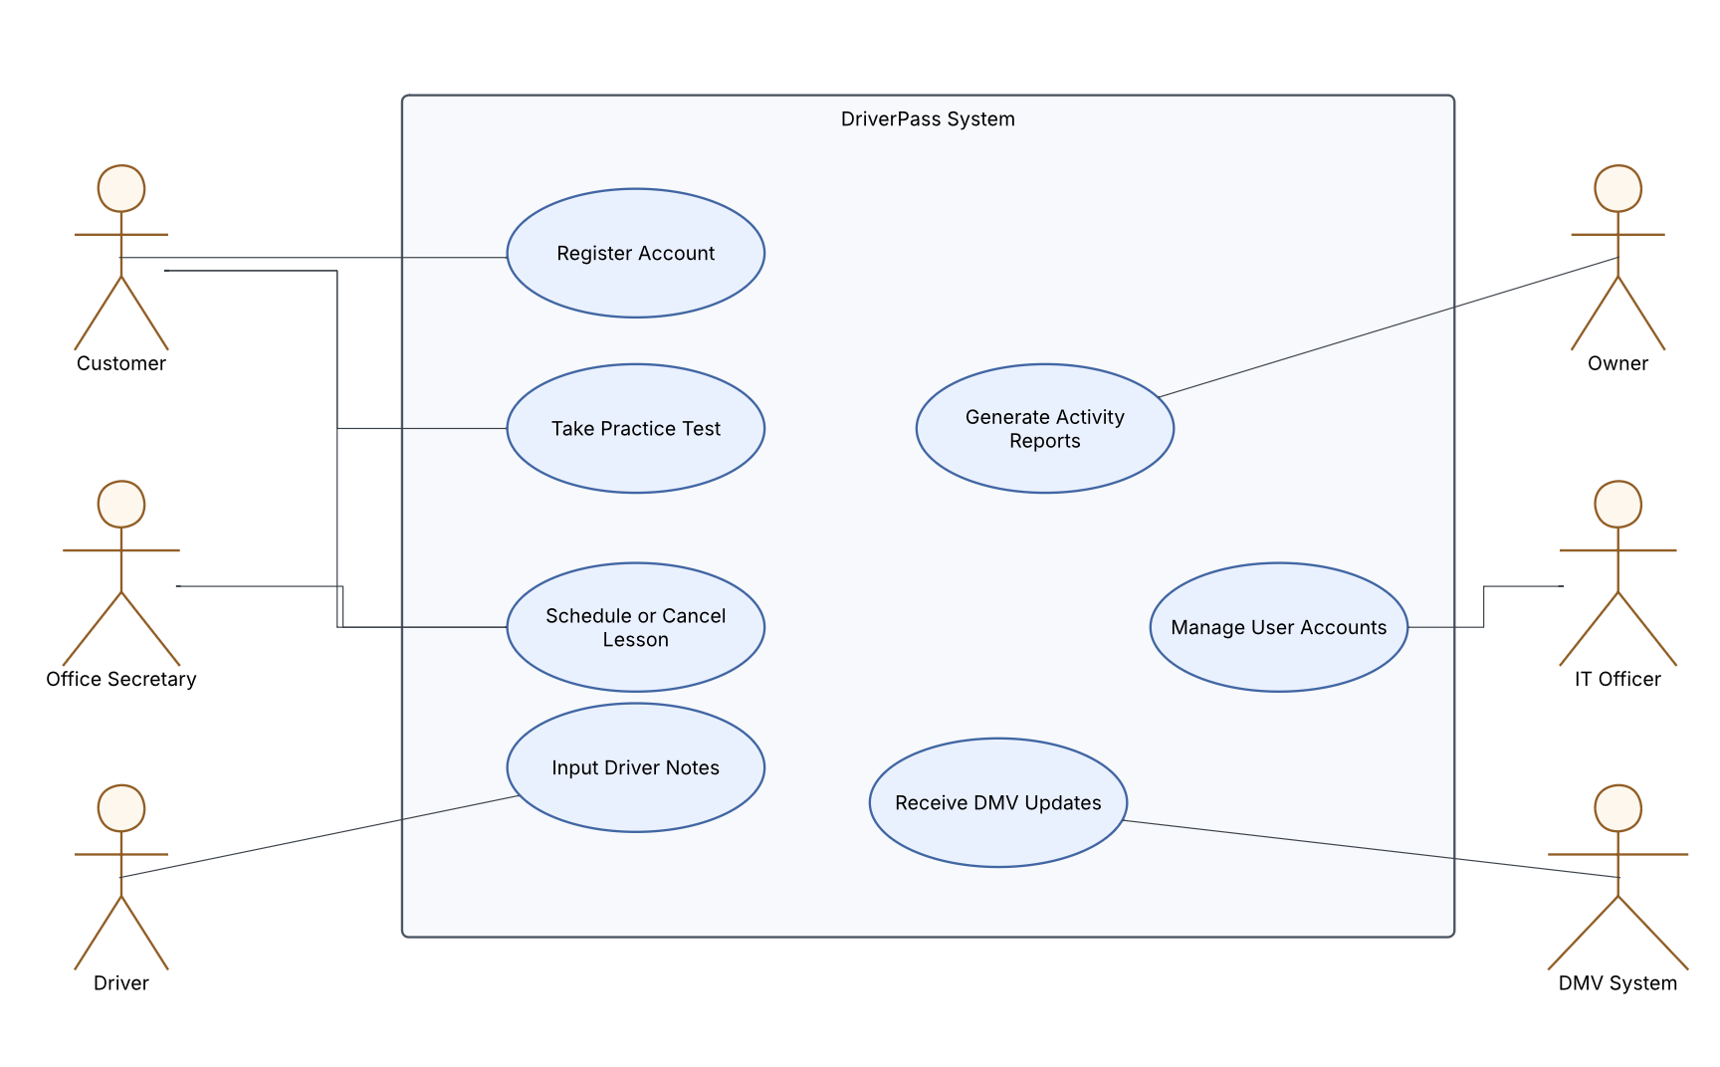

UML Activity Diagrams
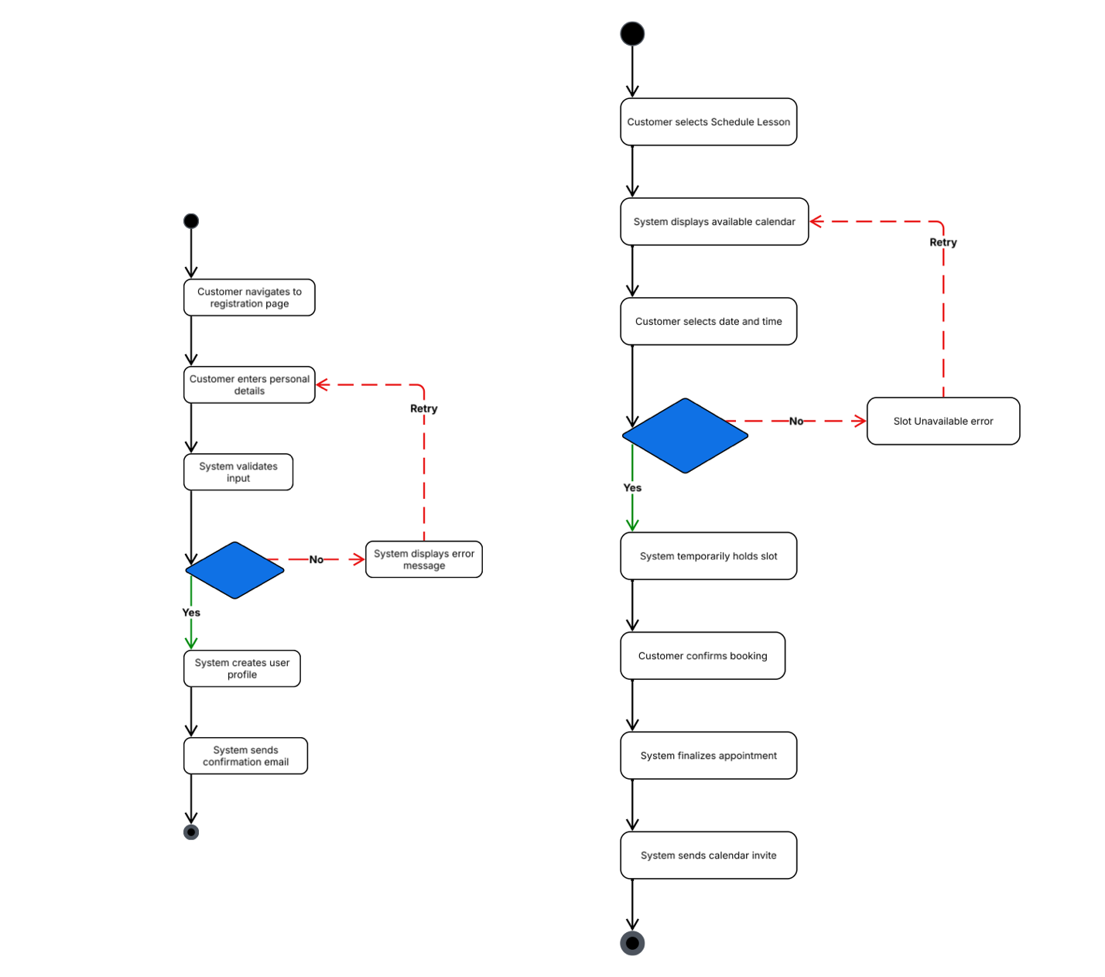

UML Sequence Diagram
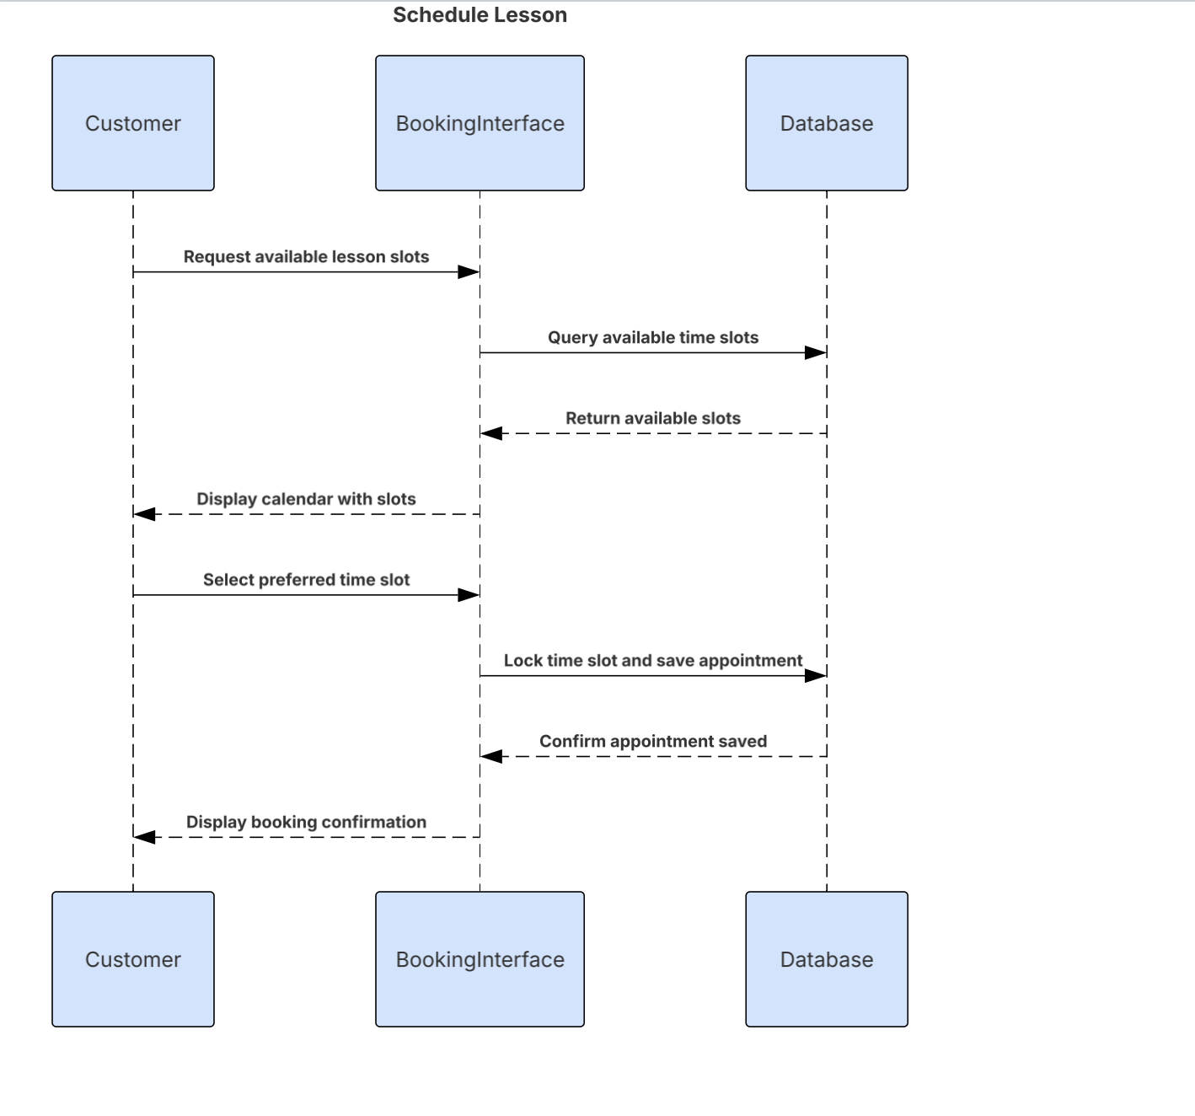

UML Class Diagram
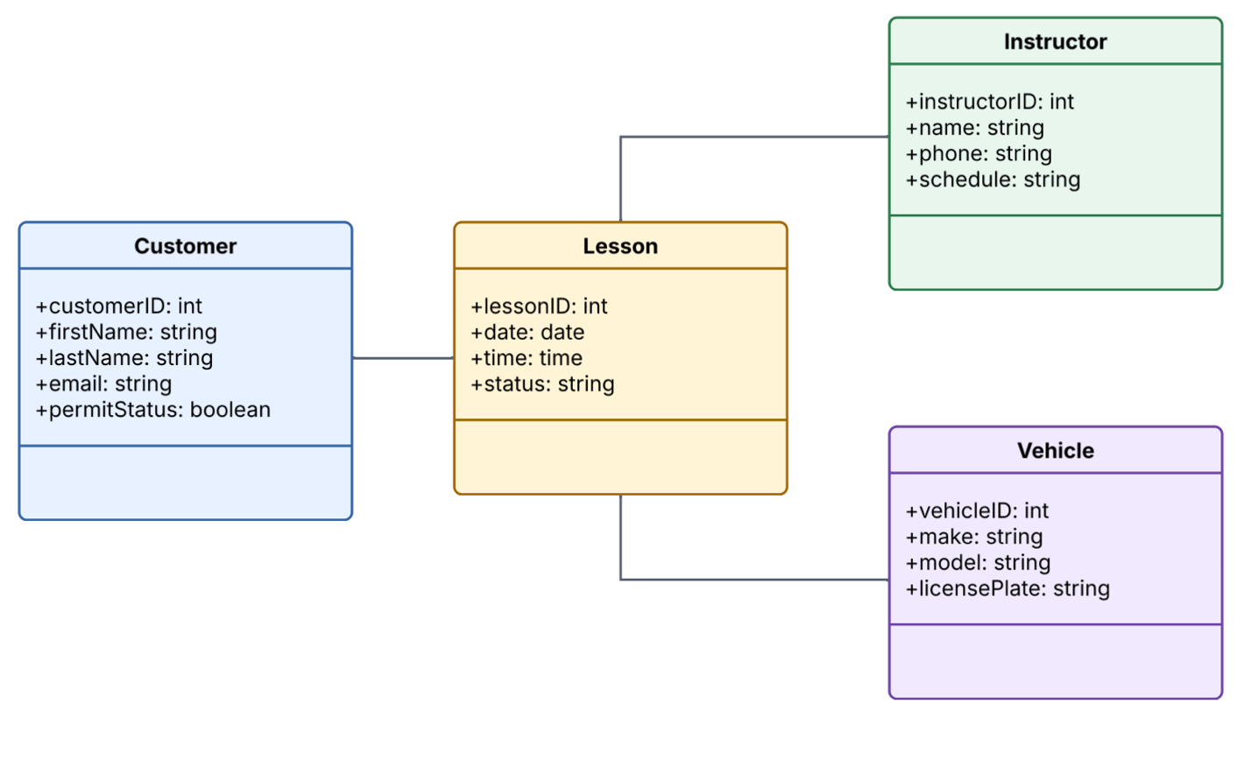

Technical Requirements

Hardware Requirements
DriverPass won’t need to purchase any physical servers since the system will be hosted in the cloud. The office staff can just use standard laptops or desktop computers to access the admin dashboard. The driving instructors will need tablets or smartphones so they can pull up their schedules and type in driver notes while they are out in the vehicles.
Software Requirements
The system will run as a web application, meaning customers and staff can just log in using normal browsers like Chrome or Safari without needing to download a separate app. For the backend, we will need a SQL database (like MYSQL) to keep track of the user accounts, lesson schedules, and billing information.
Infrastructure and Tools
The system’s infrastructure will rely on a cloud provider like AWS or Microsoft Azure, which makes it easy to add more space as the driving school gets more students. For tools, we must set up SSL encryption to protect everyone’s personal data when they use the site. We also need an automated daily backup tool, so the company doesn’t lose any records if a server ever goes down.

